**Cardiovascular System**

**Introduction**

**Basic Histological Structure of Arteries and Vein**

* They vary in diameter but all have some features in common.
* The wall is made up of three layers:
  + 1. ***Tunica intima*** (tunica = coat) – the innermost layer
    2. ***Tunica media*** – the middle layer
    3. ***Tunica adventitia***– the outermost layer.

**Arteriosclerosis**

* It literally means “hardening of arteries”. It is a genetic term for 3 patterns of vascular disease:

1. **Atherosclerosis**; characterised by the formation of intimal **fibrous plaques** that often have a central core rich in **lipid**.
2. **Calcific** deposits in medium sized muscular arteries.
3. **Disease** of small arteries and arterioles.

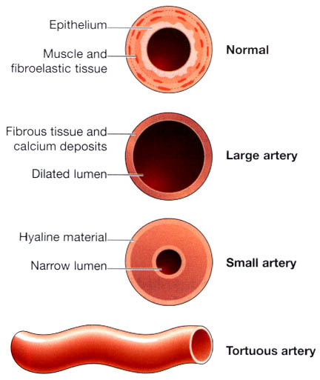

**Fig: Arteriosclerotic arteries.**

**Atherosclerosis**

* It is a complex disease characterised by **thickening** or **hardening of arteries** due to accumulation of lipids (particularly cholesterol, free and esterified), collagen, fibrous tissue, calcium deposits, etc. in the inner arterial wall.
* It is a progressive disorder that narrows and ultimately blocks the arteries.
* Mostly affected arteries includes coronary arteries, leading to myocardial infarction or heart attack.

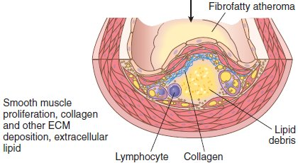

**Fig: well-developed plague**

* Atheromatous plaques are raised lesions composed of soft, yellow, lipid cores (mainly cholesterol and cholesterol esters, with necrotic debris) covered by a firm, white fibrous caps.
* Atherosclerotic plaques can mechanically obstruct vascular lumina and are prone to rupture, resulting in catastrophic vessel thrombosis.
* Plaques also weaken the underlying media, sometimes leading to aneurysm formation.

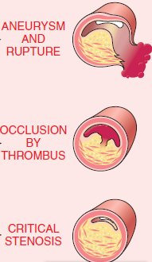

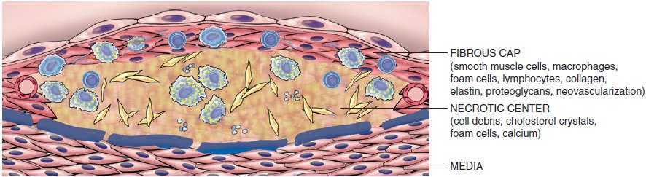

**Fig: The basic structure of an atheromatous plaque.**

**Risk factors:**

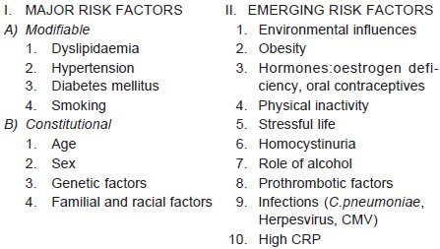

**Causes:**

1. Increase in plasma cholesterol and LDL level
2. Decrease in plasma HDL level
3. Certain diseases are associated with atherosclerosis includes diabetes mellitus, hyperlipoproteinamias, nephrotic syndrome, hypothyroidism, etc.
4. Certain factors like obesity, high consumption of saturated fat, excessive smoking, lack of physical exercise, hypertension, stress, etc.

**Pathophysiology :**

The major events that may occur are:

* 1. Endothelial cell injury
  2. Endothelial dysfunction
  3. Macrophage activation
  4. Proliferation of SMC (smooth muscle cells)
  5. Engulfment of lipid

**Fig: Pathogenesis.**

**Complications:**

**Major complications:**

* + Myocardial infarction (heart attack)
  + Cerebral infarction (stroke)
  + Aortic aneurysms

1. Aorta— Aneurysm formation, thrombosis and embolisation to other organs.
2. Heart— Myocardial infarction, ischemic heart disease.
3. Brain— Chronic ischemic brain damage, cerebral infarction.
4. Small intestine— Ischemic bowel disease, infarction.
5. Lower extremities— Intermittent claudication (cramp), gangrene.

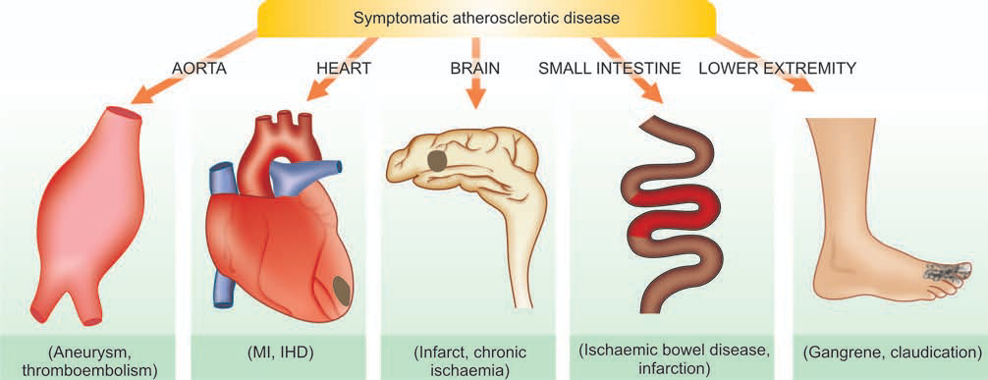

**Fig: Major forms of symptomatic atherosclerotic disease.**

**Thromboangiitis obliterans (Buerger's disease)**

* In this condition there is acute **inflammation with thrombosis** of affecting small and medium-sized arteries, mainly in the lower limbs.
* It occurs most commonly in men between the ages of 20 and 40 years and is associated with heavy cigarette smoking.
* The condition may be caused by an **immune response** to an **antigen**, possibly a **tobacco protein**.
* The condition may become chronic and the vessel walls become fibrosed, lose their elasticity and do not dilate during exercise.
* The individual suffers from acute ischemic pain and, as the disease progresses, the distance walked with comfort is gradually reduced.
* In the long term the skin may ulcerate and, in extreme cases, gangrene may develop.

**Pathogenesis:**

Following possible mechanisms have been suggested:

* Association with heavy cigarette smoking. This has led to the hypothesis that ***tobacco products*** cause either direct endothelial damage leading to hypercoagulability and thrombosis, or it is a result in hypersensitivity to tobacco products. In support is the demonstration of anti-endothelial cell antibodies (AECAs).
* ***Genetic factors*** play a role as the disease has familial occurrence and has HLA association. An increased prevalence is seen in individuals with HLA-A9 and HLA-B5 antigens. It is seen more commonly in persons from Israel, Japan and in India.

**Aneurysms**

* An aneurysm is defined as a permanent abnormal dilatation of a blood vessel occurring due to congenital or acquired weakening or destruction of the vessel wall.
* Most commonly, aneurysms involve large elastic arteries, especially the aorta and its major branches.
* Aneurysms can cause various ill-effects such as thrombosis and thromboembolism, alteration in the flow of blood, rupture of the vessel and compression of neighbouring structures.
* It Can be:
  + - **Saccular** having large spherical outpouching.
    - **Fusiform** having slow spindle-shaped dilatation.
    - **Cylindrical** with a continuous parallel dilatation.
    - **Serpentine or varicose** which has tortuous dilatation of the vessel.
    - **Racemose or circoid** having mass of intercommunicating small arteries and veins.
    - **Dissecting** occur mainly in the arch of the aorta due to infiltration of blood between the endothelium and tunica media, beginning at a site of endothelial damage.

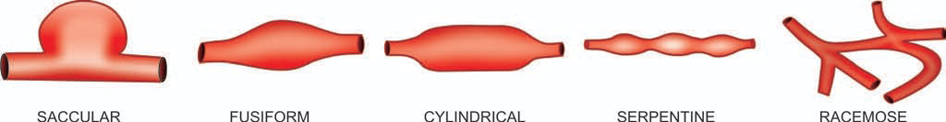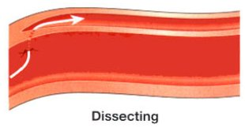

**Fig: Common shapes of aneurysms of various types.**

**Heart Diseases**

**Myocardial infarction (Heart Attack)**

* Acute myocardial infarction (MI) is the most important and feared consequence of coronary artery disease.
* Many patients may die within the first few hours of the onset, while remainder suffer from effects of impaired cardiac function.
* Disease of the coronary arteries which carry the blood supply to the heart muscle (or myocardium).
* This results in narrowing of the arteries until finally they are unable to transport sufficient blood for the myocardium to function anciently.

**One of two things may happen:**

* 1. If the narrowing of the coronary arteries occurs gradually, then the individual concerned will develop either angina pectoris or signs of a failing heart: irregular rhythm, breathlessness, cyanosis and edema.
  2. If the narrowing occurs suddenly or leads to complete blockage (occlusion) of a major branch of one of the coronary arteries, then the victim collapses with acute pain and distress.
* In developed countries, acute MI accounts for 10-25% of all deaths.
* Acute MI may virtually occur at all ages, though the incidence is higher in the elderly.
* About 5% of heart attacks occur in young people under the age of 40 years, particularly in those with major risk factors to develop atherosclerosis like hypertension, diabetes mellitus, cigarette smoking and dyslipidaemia with familial hypercholesterolaemia.
* Males significantly higher risk of developing acute MI as compared to females. Women during reproductive period have remarkably low incidence of acute MI, probably due to the protective influence of oestrogen.
* Localised area of cardiac muscle coagulative necrosis due to ischemia or necrosis of heart muscle resulting from ischemia.
* It is a disease characterised by ischemia of the heart muscles, usually due to coronary artery disease. Generally it is called necrosis of heart muscle.
* Mechanism:
  1. Coronary artery atherosclerosis with plaque rupture and superimposed thrombus formation
  2. Coronary artery spasm

**Pathogenesis:**

**Clinical Features:**

* Substernal pain with radiation to neck, jaw or back
* Severe crushing pain
* Nausea and vomiting
* Dyspnea, dysarrhythamia
* Pallor, cyanosis
* Fever
* Initial increase in pulse and BP

**Causes:**

* The precise cause is not known, but a wide range of factors play a part in inducing
  + Coronary artery disease
  + Heredity is an important factor
  + More common in men than in women
  + More common in those in sedentary occupations than in those who lead a more physically active life
  + More likely to occur in those with high blood pressure than in those with normal blood pressure
  + Obesity is a contributory factor
  + More associated with a high level of cholesterol in the blood
  + has been linked with an excessive consumption of animal, as opposed to vegetable.
  + Important factors seem to be the saturated fatty acids (low-density and very low-density lipoproteins (LDLs and VLDLs)

**Complications:**

* Cardiac arrhythmia
* Congestive heart failure
* Fibrinous pericarditis
* Cardiac rupture
* Thromboembolism and mural thrombus
* Cardiogenic shock
* Ventricular aneurys

The most common causes of death after acute myocardial infarction are

* 1. decreased cardiac output.
  2. damming of blood in the pulmonary blood vessels and then death resulting from pulmonary edema.
  3. ﬁbrillation of the heart.
  4. Occasionally rupture of the heart.

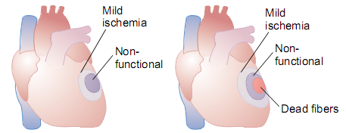

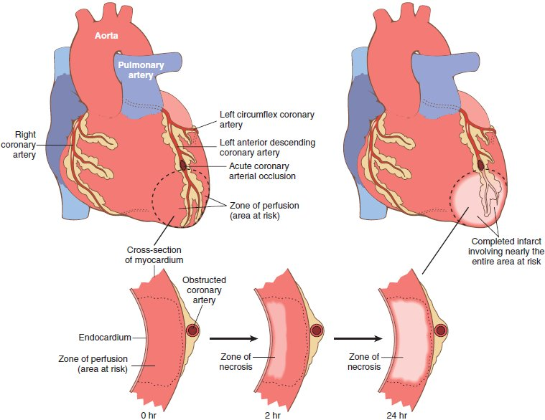

**Fig:** Progression of myocardial necrosis after coronary artery occlusion.

**Table: Evolution of Morphologic Changes in Myocardial Infarction**

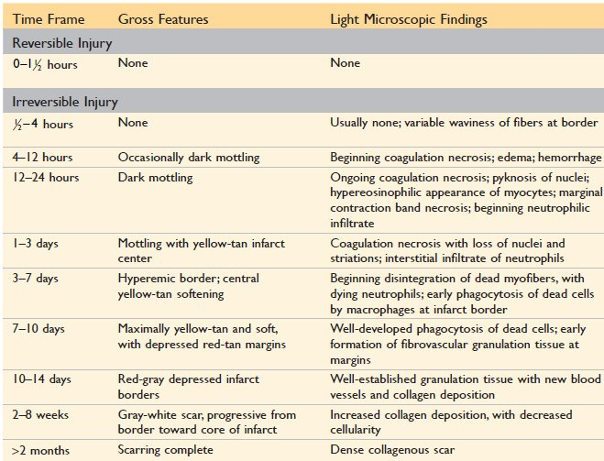

**ECG abnormalities:**

1. ST segment abnormalities and T wave inversion
2. Q wave representing transmural infarct

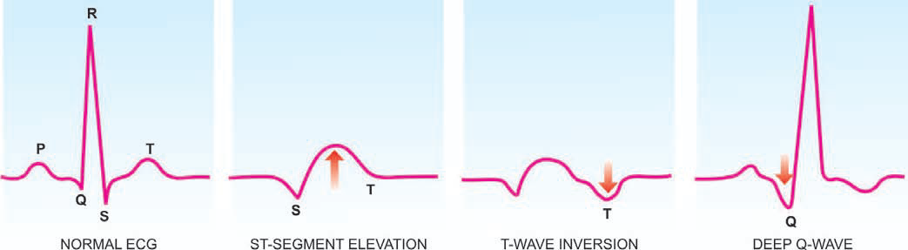

**Fig: Some common ECG changes in acute myocardial infarction.**

**Lab Findings:**

|  |  |  |  |
| --- | --- | --- | --- |
| **Marker** | **Elevated by** | **Peak** | **Returns normal by** |
| Troponin (TnI, TnT) | 2-4 hrs | 48 hrs | 7-10 days |
| Creatinine kinase (CK-MB) | 2-4 hrs | 48 hrs | 72 hrs |

* Troponin is a component of the heart's muscle fibers
* When the heart is deprived of oxygen, the muscle fibers are damaged, and their components (including troponin) leak in to the bloodstream.
* 3 to 4 hours after a heart attack, blood levels of two types of troponin (cTnI and cTnT) begin to increase.
* Levels peak at about 12 to 16 hours and stay elevated for up to 2 weeks.
* After a heart attack, levels of CK-MB follow a particular, predictable pattern.
  + CK-MB levels begin to rise within about 3 to 6 hours after a heart attack, with the highest CK-MB levels occurring about 12 to 24 hours after the heart attack.
  + Within about 12 to 48 hours of a heart attack, the CK-MB in the bloodstream will return to normal levels.

**Rheumatic Heart Disease**

* Rheumatic fever (RF) is an acute, immunologically mediated, multisystem inflammatory disease that occurs after group A β-hemolytic streptococcal infections (usually pharyngitis, but also rarely with infections at other sites such as skin).
* Rheumatic heart disease (RHD) is the cardiac manifestation of rheumatic fever.
* It is associated with inflammation of all parts of the heart, valves, myocardium, or pericardium but valvular inflammation and scarring produces the most important clinical features.
* It is characterized principally by deforming fibrotic valvular disease (particularly mitral stenosis), which can produce permanent dysfunction and severe, sometimes fatal, cardiac dysfunction decades later.

**Pathogenesis:**

* It is proposed that antibodies directed against the M proteins of certain strains of streptococci cross-react with tissue glycoproteins in the heart, joints, and other tissues.
* The onset of symptoms usually 2 to 3 weeks after infection
* Common in female > males, 5-15 years

**Fig: Pathogenesis of RHD**

**Acute Rheumatic heart disease:**

1. Myocarditis – **Aschoff** **body**: inflammatory lesions , fibrinoid necrosis surrounded by lymphocytes, plasma cells and activated macrophages (Anitschkow cells).
2. Fibrinous pericarditis
3. Pancarditis (Aschoff bodies can be found in any of the three layers of the heart—pericardium, myocardium, or endocardium (including valves).

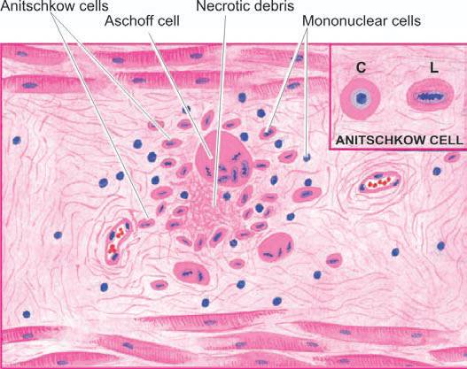

**Fig: An Aschoff body (granulomatous stage) in the myocardium**

**Chronic Rheumatic heart disease:**

1. Mitral and aortic valvular fibrosis
2. Complication
   * Mitral and/or aortic stenosis and/or regurgitation and Chronic Heart Failure
   * Infective (bacterial) endocarditis

**Infective Endocarditis:**

* + Infective endocarditis is a serious infection mandating prompt diagnosis and intervention.
  + Microbial invasion of heart valves or mural endocardium—often with destruction of the underlying cardiac tissues—characteristically results in bulky, friable ***vegetations***composed of necrotic debris, thrombus, and organisms.

**Congenital Heart Disease**

* Congenital heart disease is the abnormality of the heart present from birth.
* It is the most common and important form of heart disease in the early years of life and is present in about 0.5% of newborn children.
* They account for 20% to 30% of all birth defects
* Congenital heart disease affects 6 to 8 of every 1000 liveborn infants.
* The incidence is higher in premature infants.
* The cause of congenital heart disease is unknown in majority of cases.
* It is attributed to multifactorial inheritance involving **genetic** and **environmental** influences.
* **Other factors** like rubella infection to the mother during pregnancy, drugs taken by the mother and heavy alcohol drinking by the mother, have all been implicated in causing *in utero* foetal injury resulting in congenital malformations of the heart.

**CLASSIFICATION:**

* 1. **Left-to-right Shunts (acyanotic heart disease)**
  2. **Right-to-left Shunts (cyanotic heart disease)**
  3. **Obstructions congenital heart disease**
* A *shunt* is an abnormal blood flow or communication between chambers or blood vessels.
* Depending on pressure relationships, shunts permit the flow of blood from the left to the right side of the heart (or vice versa).
* With ***right-to-left shunt,*** a dusky blueness of the skin (cyanosis) results because the pulmonary circulation is bypassed and poorly oxygenated blood enters the systemic circulation.
* By contrast, ***left-to-right shunts*** increase pulmonary blood flow and are not associated (at least initially) with cyanosis.
* Some congenital anomalies ***obstruct vascular flow****—*bynarrowing the chambers (***stenosis***), valves, or major blood vessels; a malformation characterized by complete obstruction is called an ***atresia****.*
* Detected by **ECHO** (Echocardiography), **ECG** (Electrocardiographic), **Chest X-ray**, etc.

1. **Left-to-right Shunts (acyanotic heart disease)**

* Shunting of blood from left-to-right side of the heart, there is volume overload on the right heart producing **pulmonary hypertension** and **right ventricular hypertrophy**.
* At a later stage, the pressure on the right side is higher than on the left side creating late cyanotic heart disease.
* They include:
  + - 1. ***Atrial septal defects (ASDs),***
      2. ***Ventricular septal defects (VSDs),***
      3. ***Patent ductus arteriosus (PDA*).**
* ASDs typically increase pulmonary blood volumes, while VSDs and PDAs cause both increased pulmonary blood flows and pressures.

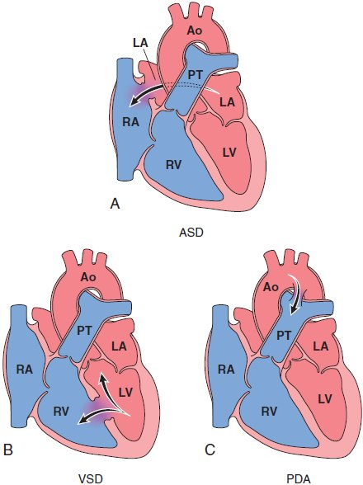

**Fig: Common congenital left-to-right shunts.**

**A, Atrial septal defect (ASD).**

**B, Ventricular septal defect (VSD).**

**C, Patent ductus arteriosus (PDA).**

Ao, aorta; LA, left atrium; LV, left ventricle; PT, pulmonary trunk; RA, right atrium; RV, right ventricle.

1. **Ventricular septal defects (VSDs):**

* Most common congenital anomaly of the heart and comprises about 30% of all congenital heart diseases.
* Recognised early in life.
* The smaller defects often close spontaneously, while larger defects remain patent and produce significant effects.
* Depending upon the location of the defect, VSD may be of the following types:
  1. ***membranous septum (90%)*** and is very close to the bundle of His.
  2. ***(10%)*** below the pulmonary valve (***subpulmonic****),* below the aortic valve (***subaortic****)*

It is the Direct communication between the ventricular chambers

* **Small VSD**:
  + May be asymptomatic and closes spontaneously
  + May produce a jet stream that damage the endocardium and increases the risk of infectious endocarditis
* **Large VSD**:
  + May lead to pulmonary hypertension, Right Ventricle Hypertrophy, reversal of the shunt, and late cyanosis (**Eisenmenger syndrome**)
* **Auscultation**:
  + Systolic murmur
* VSDs are commonly associated with other heart defects like **enlargement and haemodynamic changes in tricuspid and pulmonary valves, and mitral and aortic valves, hypertrophy of right atrium, etc.**
* **Treatment**: Surgical correction of large defects

1. **Atrial septal defects (ASDs):**

It is the Direct communication between the atrial chambers

* **Most common type**: i) ***Ostium primum***, initially separates the two, rare, more serious, defect lies low down **near the valves**, require surgical closure. ii) ***Ostium secundum***, a opening between two atrium, most have no symptoms, lies **away from the valves**, detected by heart murmur, treated with an umbrella-shaped closure device passed to the heart through the venous system under X-ray and ultrasound control.
* **Complications:**
  + **Eisenmenger syndrome** (Pulmonary HTN, reversal of flow and shunting of unoxygenated blood into the systemic circulation, development of cyanosis, increased no. of RBCs i.e. polycythaemia)
  + **Paradoxical emboli** (embolus carried from the venous side of circulation to the arterial side or vice versa, through arteriovenous communication)

1. **Patent ductus arteriosus (PDA):**

Direct communication between the aorta and pulmonary artery due to continued patency of the ductus arteriosis after birth

* Associated with prematurity and congenital rubella infections
* **Clinical**: machinery murmur, late cyanosis and congestive heart disease
* **Complication**: Eisenmenger syndrome

1. **Right-to-left Shunts (cyanotic heart disease)**

* In conditions where there is shunting of blood from right side to the left side of the heart, there is entry of **poorly oxygenated blood** into **systemic circulation** resulting in early **cyanosis**.

1. **Tetralogy of fallot:**

Most common, found in about 10% of children with anomalies of the heart.

Morphologic features:

1. Ventricular septal defect (**VSD**) *(‘shunt’).*
2. **Displacement** of the aorta to right.
3. Pulmonary stenosis *(‘****obstruction****’).*
4. Right ventricular **hypertrophy**.
5. **Transposition of great arteries**
   * **Complex malformations** as regards position of the aorta, pulmonary trunk, atrioventricular orifices and the position of atria in relation to ventricles.
6. **Persistent truncus arteriosus** 
   * rare anomaly
   * the **arch** that normally **separates** the aorta from the pulmonary artery **fails** to **develop**. This results in a single large **common** **vessel** receiving blood from the right as well as left ventricle.
   * There is left-to-right shunt and frequently early systemic cyanosis.
7. **Tricuspid atresia and stenosis**
   * rare anomalies.
   * associated **pulmonary** **stenosis** or **pulmonary** **atresia** (or **absence**).
     + In tricuspid **atresia**, there is **absence** of tricuspid orifice.
     + In tricuspid **stenosis**, the tricuspid ring is **small** and the valve cusps are **malformed**.
8. **Obstructions congenital heart disease**

Congenital obstruction to blood flow may result from:

* + obstruction in the **aorta** due to narrowing (*coarctation of aorta),*
  + obstruction to outflow from the **left ventricle** (*aortic stenosis and atresia),*
  + obstruction to outflow from the **right ventricle** (*pulmonary stenosis and atresia).*

